DESIGN PATTERNS AND PRINCIPLES

Exercise 1: Implementing the Singleton Pattern Scenario

1. **Project Structure:-**

* SingletonPatternExample

├── Logger.java

├── LoggerInterface.java

├── LoggerTest.java

**2. LoggerInterface.java (For Interface Segregation Principle):-**

public interface LoggerInterface {

void log(String message);

}

**3. Logger.java – Singleton Implementation:-**

Applying:

* Single Responsibility Principle – Handles only logging.
* Open/Closed Principle – Can extend log strategy without modifying this.
* Liskov Substitution Principle – Uses interface LoggerInterface.
* Interface Segregation Principle – Keeps logging responsibilities in the interface.
* Dependency Inversion Principle – Not tightly coupled to usage.

**Code:-**

public class Logger implements LoggerInterface {

// Private static instance (Eager Initialization)

private static final Logger instance = new Logger();

// Private constructor to prevent instantiation

private Logger() {

System.out.println("Logger instance created.");

}

// Public method to provide access to the instance

public static Logger getInstance() {

return instance;

}

@Override

public void log(String message) {

System.out.println("[LOG] " + message);

}

}

### **4. LoggerTest.java – Verifying Singleton:-**

public class LoggerTest {

public static void main(String[] args) {

LoggerInterface logger1 = Logger.getInstance();

LoggerInterface logger2 = Logger.getInstance();

logger1.log("Singleton pattern test message.");

logger2.log("Same instance check.");

// Check if both instances are same

if (logger1 == logger2) {

System.out.println("Both logger1 and logger2 are the same instance.");

} else {

System.out.println("Different instances detected. Singleton failed!");

}

}

}

**5.MAIN CODE:-**

// All-in-One Java File demonstrating Singleton Pattern with SOLID principles

interface LoggerInterface {

void log(String message);

}

// Logger class following Singleton Design Pattern and SOLID Principles

class Logger implements LoggerInterface {

// Eager initialization of the single instance

private static final Logger instance = new Logger();

// Private constructor to prevent external instantiation

private Logger() {

System.out.println("Logger instance created.");

}

// Public static method to provide access to the single instance

public static Logger getInstance() {

return instance;

}

// Method to perform logging

@Override

public void log(String message) {

System.out.println("[LOG]: " + message);

}

}

// Test class to verify Singleton behavior

public class SingletonPatternExample {

public static void main(String[] args) {

LoggerInterface logger1 = Logger.getInstance();

LoggerInterface logger2 = Logger.getInstance();

logger1.log("Logging from logger1.");

logger2.log("Logging from logger2.");

// Verifying both references point to the same instance

if (logger1 == logger2) {

System.out.println(" Both logger1 and logger2 are the same instance. Singleton works!");

} else {

System.out.println(" Different instances detected. Singleton failed.");

}

}

}

**OUTPUT:-**

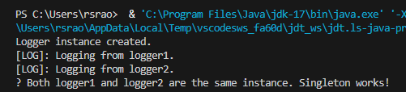

**Exercise 2: Implementing the Factory Method Pattern**

**Scenario**

CODE:-

// 1. Document Interface (ISP, DIP)

interface Document {

void open();

}

// 2. Concrete Document Classes (SRP, LSP)

class WordDocument implements Document {

@Override

public void open() {

System.out.println("Opening a Word Document.");

}

}

class PdfDocument implements Document {

@Override

public void open() {

System.out.println("Opening a PDF Document.");

}

}

class ExcelDocument implements Document {

@Override

public void open() {

System.out.println("Opening an Excel Document.");

}

}

// 3. Abstract Factory Class (OCP, DIP)

abstract class DocumentFactory {

// Factory Method

public abstract Document createDocument();

}

// 4. Concrete Factories for each Document Type (OCP)

class WordDocumentFactory extends DocumentFactory {

@Override

public Document createDocument() {

return new WordDocument();

}

}

class PdfDocumentFactory extends DocumentFactory {

@Override

public Document createDocument() {

return new PdfDocument();

}

}

class ExcelDocumentFactory extends DocumentFactory {

@Override

public Document createDocument() {

return new ExcelDocument();

}

}

// 5. Test class (Client Code)

public class FactoryMethodPatternExample {

public static void main(String[] args) {

// Word document creation

DocumentFactory wordFactory = new WordDocumentFactory();

Document wordDoc = wordFactory.createDocument();

wordDoc.open();

// PDF document creation

DocumentFactory pdfFactory = new PdfDocumentFactory();

Document pdfDoc = pdfFactory.createDocument();

pdfDoc.open();

// Excel document creation

DocumentFactory excelFactory = new ExcelDocumentFactory();

Document excelDoc = excelFactory.createDocument();

excelDoc.open();

// Verifying SOLID behavior

System.out.println("\n Factory Method Pattern with SOLID Principles Executed Successfully!");

}

}

OUTPUT:-

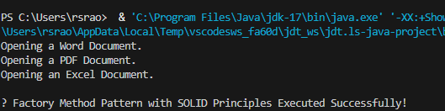

**Exercise 3: Implementing the Builder Pattern Scenario:**

Code:-

interface ComputerPlan {

String getConfiguration();

}

class Computer implements ComputerPlan {

private final String CPU;

private final String RAM;

private final String storage;

private final String graphicsCard;

private final String operatingSystem;

private Computer(Builder builder) {

this.CPU = builder.CPU;

this.RAM = builder.RAM;

this.storage = builder.storage;

this.graphicsCard = builder.graphicsCard;

this.operatingSystem = builder.operatingSystem;

}

public static class Builder {

private String CPU;

private String RAM;

private String storage;

private String graphicsCard;

private String operatingSystem;

public Builder setCPU(String CPU) {

this.CPU = CPU;

return this;

}

public Builder setRAM(String RAM) {

this.RAM = RAM;

return this;

}

public Builder setStorage(String storage) {

this.storage = storage;

return this;

}

public Builder setGraphicsCard(String graphicsCard) {

this.graphicsCard = graphicsCard;

return this;

}

public Builder setOperatingSystem(String operatingSystem) {

this.operatingSystem = operatingSystem;

return this;

}

public Computer build() {

return new Computer(this);

}

}

@Override

public String getConfiguration() {

return "CPU: " + CPU + ", RAM: " + RAM + ", Storage: " + storage +

", Graphics: " + graphicsCard + ", OS: " + operatingSystem;

}

}

public class BuilderPatternExample {

public static void main(String[] args) {

Computer basicPC = new Computer.Builder()

.setCPU("Intel i3")

.setRAM("8GB")

.setStorage("256GB SSD")

.setOperatingSystem("Windows 10")

.build();

Computer gamingPC = new Computer.Builder()

.setCPU("Intel i9")

.setRAM("32GB")

.setStorage("1TB NVMe")

.setGraphicsCard("NVIDIA RTX 4090")

.setOperatingSystem("Windows 11")

.build();

Computer linuxServer = new Computer.Builder()

.setCPU("AMD Ryzen 9")

.setRAM("64GB")

.setStorage("2TB SSD")

.setOperatingSystem("Ubuntu Server")

.build();

System.out.println("Basic PC: " + basicPC.getConfiguration());

System.out.println("Gaming PC: " + gamingPC.getConfiguration());

System.out.println("Linux Server: " + linuxServer.getConfiguration());

}

}

OUTPUT:-

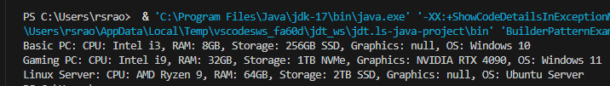

**Exercise 4: Implementing the Adapter Pattern Scenario:**

Code:-

// Target Interface

interface PaymentProcessor {

void processPayment(double amount);

}

// Adaptee 1 – PayPal (Incompatible Interface)

class PayPalGateway {

public void sendPayment(double amountInUSD) {

System.out.println("PayPal processed $" + amountInUSD + " USD.");

}

}

// Adaptee 2 – Razorpay (Incompatible Interface)

class RazorpayGateway {

public void makePaymentInINR(double amountInINR) {

System.out.println(" Razorpay processed ₹" + amountInINR + " INR.");

}

}

// Adapter 1 – PayPal Adapter

class PayPalAdapter implements PaymentProcessor {

private PayPalGateway paypal;

public PayPalAdapter(PayPalGateway paypal) {

this.paypal = paypal;

}

@Override

public void processPayment(double amount) {

paypal.sendPayment(amount); // Delegating to PayPal-specific method

}

}

// Adapter 2 – Razorpay Adapter

class RazorpayAdapter implements PaymentProcessor {

private RazorpayGateway razorpay;

public RazorpayAdapter(RazorpayGateway razorpay) {

this.razorpay = razorpay;

}

@Override

public void processPayment(double amount) {

razorpay.makePaymentInINR(amount); // Delegating to Razorpay-specific method

}

}

// Client code – Test class

public class AdapterPatternExample {

public static void main(String[] args) {

PaymentProcessor paypalProcessor = new PayPalAdapter(new PayPalGateway());

PaymentProcessor razorpayProcessor = new RazorpayAdapter(new RazorpayGateway());

System.out.println("Processing Payments via Adapter Pattern:\n");

paypalProcessor.processPayment(100.0);

razorpayProcessor.processPayment(8500.0);

System.out.println("\nAdapter Pattern Successfully Demonstrated.");

}

}

OUTPUT:-

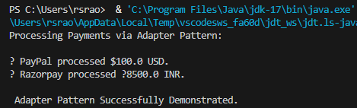

**Exercise 5: Implementing the Decorator Pattern**

**Scenario:**

Code:-

// Step 2: Component Interface (Defines base notification behavior)

interface Notifier {

void send(String message);

}

// Step 3: Concrete Component (Sends notification via Email)

class EmailNotifier implements Notifier {

@Override

public void send(String message) {

System.out.println(" Email sent: " + message);

}

}

// Step 4: Abstract Decorator (Wraps a Notifier and allows dynamic enhancements)

abstract class NotifierDecorator implements Notifier {

protected Notifier notifier; // Reference to another Notifier

public NotifierDecorator(Notifier notifier) {

this.notifier = notifier;

}

@Override

public void send(String message) {

notifier.send(message); // Delegate base notification

}

}

// Step 4: Concrete Decorator – SMS

class SMSNotifierDecorator extends NotifierDecorator {

public SMSNotifierDecorator(Notifier notifier) {

super(notifier);

}

@Override

public void send(String message) {

super.send(message); // Send original notification

sendSMS(message); // Add SMS functionality

}

private void sendSMS(String message) {

System.out.println("SMS sent: " + message);

}

}

// Step 4: Concrete Decorator – Slack

class SlackNotifierDecorator extends NotifierDecorator {

public SlackNotifierDecorator(Notifier notifier) {

super(notifier);

}

@Override

public void send(String message) {

super.send(message); // Send original + previous notifications

sendSlack(message); // Add Slack functionality

}

private void sendSlack(String message) {

System.out.println(" Slack message sent: " + message);

}

}

// Step 5: Test Class

public class DecoratorPatternExample {

public static void main(String[] args) {

// Base notifier: Email only

Notifier emailNotifier = new EmailNotifier();

// Email + SMS

Notifier smsEmailNotifier = new SMSNotifierDecorator(emailNotifier);

// Email + SMS + Slack

Notifier fullNotifier = new SlackNotifierDecorator(smsEmailNotifier);

// Test: send a notification

System.out.println(" Sending notification through all channels:\n");

fullNotifier.send("Your order #12345 has been shipped.");

System.out.println("\nDecorator Pattern implemented with SOLID principles.");

}

}

OUTPUT:-

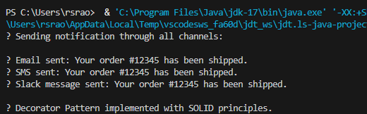

**Exercise 6: Implementing the Proxy Pattern**

**Scenario:**

Code:-

// Step 2: Subject Interface

interface Image {

void display();

}

// Step 3: Real Subject – Loads image from remote server

class RealImage implements Image {

private String filename;

public RealImage(String filename) {

this.filename = filename;

loadFromRemoteServer();

}

private void loadFromRemoteServer() {

System.out.println(" Loading image from remote server: " + filename);

}

@Override

public void display() {

System.out.println(" Displaying image: " + filename);

}

}

// Step 4: Proxy Class – Adds lazy loading and caching

class ProxyImage implements Image {

private String filename;

private RealImage realImage;

public ProxyImage(String filename) {

this.filename = filename;

}

@Override

public void display() {

if (realImage == null) {

System.out.println(" Image not loaded yet. Loading now...");

realImage = new RealImage(filename); // Lazy loading

} else {

System.out.println(" Image already loaded. Using cache...");

}

realImage.display(); // Delegate to real image

}

}

// Step 5: Test Class

public class ProxyPatternExample {

public static void main(String[] args) {

Image image1 = new ProxyImage("nature.png");

System.out.println("\n[First display call]");

image1.display(); // Loads from server

System.out.println("\n[Second display call]");

image1.display(); // Uses cached image

System.out.println("\n Proxy Pattern executed with lazy loading and caching.");

}

}

OUTPUT:-

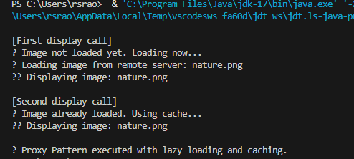

**Exercise 7: Implementing the Observer Pattern**

Code:-

import java.util.*;

// Step 2: Subject Interface

interface Stock {

void register(Observer o);

void deregister(Observer o);

void notifyObservers();

void setPrice(double price);

}

// Step 3: Concrete Subject – StockMarket

class StockMarket implements Stock {

private List<Observer> observers = new ArrayList<>();

private double stockPrice;

@Override

public void register(Observer o) {

observers.add(o);

System.out.println(" Observer registered: " + o.getName());

}

@Override

public void deregister(Observer o) {

observers.remove(o);

System.out.println(" Observer deregistered: " + o.getName());

}

@Override

public void notifyObservers() {

for (Observer o : observers) {

o.update(stockPrice);

}

}

@Override

public void setPrice(double price) {

this.stockPrice = price;

System.out.println("\n Stock price updated to $" + price);

notifyObservers();

}

}

// Step 4: Observer Interface

interface Observer {

void update(double price);

String getName();

}

// Step 5: Concrete Observer – MobileApp

class MobileApp implements Observer {

private String name;

public MobileApp(String name) {

this.name = name;

}

@Override

public void update(double price) {

System.out.println(" " + name + " received update: New stock price is $" + price);

}

@Override

public String getName() {

return name;

}

}

// Step 5: Concrete Observer – WebApp

class WebApp implements Observer {

private String name;

public WebApp(String name) {

this.name = name;

}

@Override

public void update(double price) {

System.out.println(" " + name + " received update: New stock price is $" + price);

}

@Override

public String getName() {

return name;

}

}

// Step 6: Test Class

public class ObserverPatternExample {

public static void main(String[] args) {

StockMarket stockMarket = new StockMarket();

Observer mobileApp = new MobileApp("Mobile Client");

Observer webApp = new WebApp("Web Client");

stockMarket.register(mobileApp);

stockMarket.register(webApp);

stockMarket.setPrice(102.5);

stockMarket.setPrice(108.3);

stockMarket.deregister(mobileApp);

stockMarket.setPrice(115.0);

System.out.println("\n Observer Pattern implemented successfully.");

}

}

OUTPUT:-

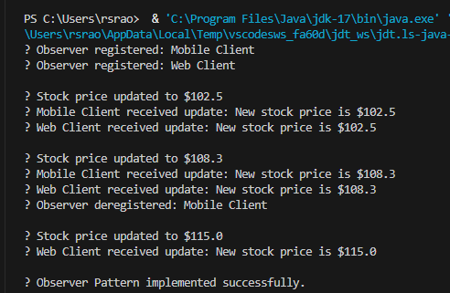

**Exercise 8: Implementing the Strategy Pattern**

**Scenario:**

Code:-

// Step 2: Strategy Interface

interface PaymentStrategy {

void pay(double amount);

}

// Step 3: Concrete Strategy – Credit Card

class CreditCardPayment implements PaymentStrategy {

private String cardNumber;

public CreditCardPayment(String cardNumber) {

this.cardNumber = cardNumber;

}

@Override

public void pay(double amount) {

System.out.println(" Paid $" + amount + " using Credit Card (**** " + cardNumber.substring(cardNumber.length() - 4) + ")");

}

}

// Step 3: Concrete Strategy – PayPal

class PayPalPayment implements PaymentStrategy {

private String email;

public PayPalPayment(String email) {

this.email = email;

}

@Override

public void pay(double amount) {

System.out.println(" Paid $" + amount + " using PayPal account: " + email);

}

}

// Step 4: Context Class

class PaymentContext {

private PaymentStrategy strategy;

public void setPaymentStrategy(PaymentStrategy strategy) {

this.strategy = strategy;

System.out.println(" Payment strategy switched to: " + strategy.getClass().getSimpleName());

}

public void executePayment(double amount) {

if (strategy != null) {

strategy.pay(amount);

} else {

System.out.println(" No payment strategy selected.");

}

}

}

// Step 5: Test Class

public class StrategyPatternExample {

public static void main(String[] args) {

PaymentContext context = new PaymentContext();

// Use Credit Card Payment

context.setPaymentStrategy(new CreditCardPayment("1234567812345678"));

context.executePayment(150.0);

// Switch to PayPal Payment

context.setPaymentStrategy(new PayPalPayment("user@example.com"));

context.executePayment(89.99);

System.out.println("\n Strategy Pattern implemented successfully.");

}

}

OUTPUT:-

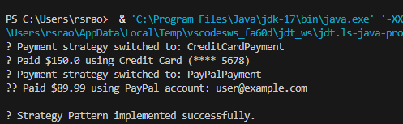

**Exercise 9: Implementing the Command Pattern**

CODE:-

// Step 2: Command Interface

interface Command {

void execute();

}

// Step 5: Receiver Class – Light

class Light {

public void turnOn() {

System.out.println(" The light is ON.");

}

public void turnOff() {

System.out.println(" The light is OFF.");

}

}

// Step 3: Concrete Command – Turn Light ON

class LightOnCommand implements Command {

private Light light;

public LightOnCommand(Light light) {

this.light = light;

}

@Override

public void execute() {

light.turnOn();

}

}

// Step 3: Concrete Command – Turn Light OFF

class LightOffCommand implements Command {

private Light light;

public LightOffCommand(Light light) {

this.light = light;

}

@Override

public void execute() {

light.turnOff();

}

}

// Step 4: Invoker Class – RemoteControl

class RemoteControl {

private Command command;

public void setCommand(Command command) {

this.command = command;

System.out.println(" Command set to: " + command.getClass().getSimpleName());

}

public void pressButton() {

if (command != null) {

command.execute();

} else {

System.out.println(" No command set.");

}

}

}

// Step 6: Test Class

public class CommandPatternExample {

public static void main(String[] args) {

Light livingRoomLight = new Light();

Command lightOn = new LightOnCommand(livingRoomLight);

Command lightOff = new LightOffCommand(livingRoomLight);

RemoteControl remote = new RemoteControl();

remote.setCommand(lightOn);

remote.pressButton();

remote.setCommand(lightOff);

remote.pressButton();

System.out.println("\n Command Pattern implemented successfully.");

}

}

OUTPUT:-

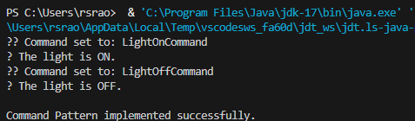

**Exercise 10: Implementing the MVC Pattern**

CODE:-

// Step 2: Model Class

class Student {

private String name;

private String id;

private String grade;

public Student(String name, String id, String grade) {

this.name = name;

this.id = id;

this.grade = grade;

}

// Getters

public String getName() { return name; }

public String getId() { return id; }

public String getGrade() { return grade; }

// Setters

public void setName(String name) { this.name = name; }

public void setId(String id) { this.id = id; }

public void setGrade(String grade) { this.grade = grade; }

}

// Step 3: View Class

class StudentView {

public void displayStudentDetails(String name, String id, String grade) {

System.out.println("\n Student Details:");

System.out.println("Name : " + name);

System.out.println("ID : " + id);

System.out.println("Grade : " + grade);

}

}

// Step 4: Controller Class

class StudentController {

private Student model;

private StudentView view;

public StudentController(Student model, StudentView view) {

this.model = model;

this.view = view;

}

// Update Model

public void setStudentName(String name) {

model.setName(name);

}

public void setStudentId(String id) {

model.setId(id);

}

public void setStudentGrade(String grade) {

model.setGrade(grade);

}

// Display using View

public void updateView() {

view.displayStudentDetails(model.getName(), model.getId(), model.getGrade());

}

}

// Step 5: Test Class (Main)

public class MVCPatternExample {

public static void main(String[] args) {

// Create Model

Student student = new Student("Alice", "S123", "A");

// Create View

StudentView view = new StudentView();

// Create Controller

StudentController controller = new StudentController(student, view);

// Initial Display

controller.updateView();

// Update details through controller

controller.setStudentName("Bob");

controller.setStudentId("S124");

controller.setStudentGrade("B+");

// Updated Display

controller.updateView();

System.out.println("\n MVC Pattern executed successfully.");

}

}

OUTPUT:-

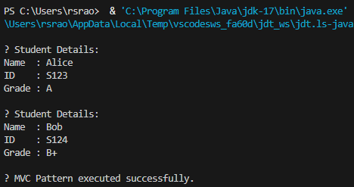

**Exercise 11: Implementing Dependency Injection**

Code:-

// Step 2: Repository Interface

interface CustomerRepository {

String findCustomerById(String id);

}

// Step 3: Concrete Repository Implementation

class CustomerRepositoryImpl implements CustomerRepository {

@Override

public String findCustomerById(String id) {

return " Customer Found: [ID: " + id + ", Name: Alice Johnson]";

}

}

// Step 4: Service Class that depends on Repository

class CustomerService {

private final CustomerRepository repository;

// Step 5: Constructor Injection

public CustomerService(CustomerRepository repository) {

this.repository = repository;

}

public void displayCustomer(String id) {

String customer = repository.findCustomerById(id);

System.out.println(customer);

}

}

// Step 6: Main Class to Test DI

public class DependencyInjectionExample {

public static void main(String[] args) {

// Create repository (dependency)

CustomerRepository repository = new CustomerRepositoryImpl();

// Inject repository into service

CustomerService service = new CustomerService(repository);

// Use service

service.displayCustomer("C101");

System.out.println("\n Dependency Injection using Constructor successfully demonstrated.");

}

}

OUTPUT:-

